Lab 04 Task
Code 1:
#include <iostream>
using namespace std;

class employee{
private:
string name;
float salary;
public:
static int count;
int num = 0;
employee(string Name, float s) : name(Name), salary(s){
count++;
num = 1000 + count;
cout << "Object Successfully Created!" << endl;
}

static void displaytotal(){
cout << "The total Number of Employees: " << count << endl;
}

void display(){
cout << "Employee ID: " << num << endl;
cout << "Employee Name: " << name << endl;
cout << "Employee Salary: " << salary << endl;
}
};

int employee :: count = 0;

int main(){
employee e1("Ali", 200.10);
employee e2("Moazam", 150.20);
employee e3("Ahmed", 300.90);
employee e4("Saad", 700.80);

e1.display();
cout << "==================" << endl;

e2.display();
cout << "==================" << endl;

e3.display();
cout << "==================" << endl;

e4.display();
cout << "==================" << endl;

e1.displaytotal();

employee e5("Fahad", 350.50);
e1.displaytotal();
}

Code Output:
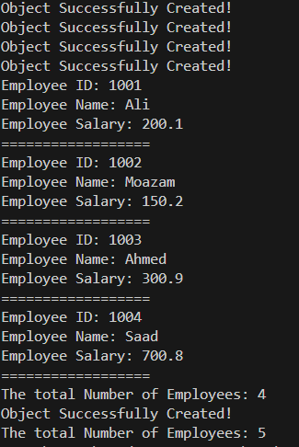
Code 2:
#include<iostream>
using namespace std;

class SpaceSatellite {
private:
const int satelliteID;
const string launchDay;
double orbitalRadius;
static int totalReportCount;

public:
SpaceSatellite(int idValue, string launchInfo, double radiusValue)
: satelliteID(idValue), launchDay(launchInfo), orbitalRadius(radiusValue) {}

void displayReport() const {
cout << "\nSatellite Report" << endl;
cout << "Satellite ID: " << satelliteID << endl;
cout << "Launch Date: " << launchDay << endl;
cout << "Orbital Radius: " << orbitalRadius << " km" << endl;

totalReportCount++;
}

void viewSatellite() {
displayReport();
totalReportCount++;
}

void adjustOrbit(double radiusChange) {
orbitalRadius += radiusChange;
cout << "Orbit adjusted. New Radius: "
<< orbitalRadius << " km" << endl;
}

static void showReportStatistics() {
cout << "\nTotal Report Views: "
<< totalReportCount << endl;
}
};

int SpaceSatellite::totalReportCount = 0;

int main() {

SpaceSatellite sat1(101, "2022-05-10", 15000);
SpaceSatellite sat2(102, "2023-08-20", 20000);

sat1.viewSatellite();
sat2.viewSatellite();
sat1.viewSatellite();

sat1.adjustOrbit(500);
sat2.adjustOrbit(-300);

SpaceSatellite::showReportStatistics();

return 0;
}

Code Output:
